Grantee: Siouxland Human Investment Partnership-Beyond the Bell
21st CCLC Local Evaluation for 2021-2022

Overview
To assist grantees with meeting the local evaluation requirements, the Iowa DOE provides a standardized form for local evaluations of the 21st CCLC Programs. Each grantee is required to complete the local evaluation form with data from the previous school year. Each grantee must submit ONE evaluation that encompasses all centers funded by the grantee. Cohorts 12-16 are to be included for reporting data for the previous school year. Reported data will be from the Summer, Fall, and Spring.
The table below lists the eight required sections of the local evaluation. Each section includes a checklist of required items to include.
The completed form should be saved with the filename <Grantee Name 21st CCLC Local Evaluation Form 2021-2022>. The form must be completed and submitted in Word format.
(Note: Instructions and clarifications are shown in RED.)
Required Section | Complete?
- General Information | x
- Introduction/Executive Summary | x
- Demographic Data | x
- GPRA Measures | x
- Local Objectives | x
- Anecdotal Data | x
- Sustainability Plans | x
- Summary and Recommendations | x

- General Information
General Information Required Elements | Complete?
Basic Information Table | x
Center Information Table | x

Basic Information Table
Item | Information
Date Form Submitted
Grantee Name | Siouxland Human Investment Partnership
Program Director Name | Jenna Andrews
Program Director E-mail | jandrews@siouxlandship.org
Program Director Phone | 712-277-3600
Evaluator Name | Consulting By Design
Evaluator E-mail | consultingbydesign@yahoo.com
Evaluator Phone | 612-804-3417
Additional Information from Grantee (optional)

Center Information Table
Cohort | Centers
(If not in a cohort, leave that cohort info blank) | (Enter Names of Centers, separated by commas)  INCLUDE SCHOOL LEVEL (i.e. Elementary, Middle, High School)
Cohort 12
Cohort 13
Cohort 14 | Hunt Elementary, Elementary
Cohort 15 | Irving Elementary/North Middle, Elementary and Middle School
Cohort 16 | Bryant Elementary, Elementary
Additional Information from Grantee (optional)

Note: If you are in Cohort 17, you will report your data next year (We always report the previous year’s data in the local evaluations).

- Introduction/Executive Summary
Introduction/Executive Summary Required Elements | Complete?
Program Implementation
- Needs Assessment Process | x
- Key People Involved | x
- Development of Objectives | x
Program Description
- Program days and hours | x
- List of activities | x
- Location of centers | x
- Attendance requirements | x
- Governance (board, director, etc.) | x
Program Highlights

Siouxland Human Investment Partnership (SHIP) delivers Beyond the Bell (BTB) in Sioux City, Iowa. The 2021-2022 evaluation includes Cohorts 14, 15, and 16. This comprises four (4) sites, including three public elementary schools and one public middle school.
The local evaluation for 2021-2022 was conducted for Siouxland Human Investment Partnerships Beyond the Bell program by Heidi Krammer-Hodge with Consulting by Design LLC, Beyond the Bell and the Sioux City Community School District.
Program Implementation. Beyond the Bell was established in 2001 as a before school, after school, and summer program in Sioux City, Iowa. During the 2021-2022 school year Beyond the Bell served 155 students during the school year and 46 during the summer in schools receiving support from Iowa Department of Education funding.
Mission:
At Beyond the Bell, we believe in helping children and families reach their full potential by providing a safe place to play, creating a quality learning environment and promoting growth.
Needs Assessment: Several steps have been taken to identify and prioritize needs for each cohort and the overall Beyond the Bell program. Each year Beyond the Bell utilizes the needs assessment for part of the local evaluation process, quality assurance, and planning process for programming. Key people involved in the process during the 2021-2022 school year included: students, parents, BTB staff, Sioux City Community School District staff, community partners, BTB and SHIP leadership, and consultants. An in-depth data collection and feedback gathering process occurs to include:
- Review of individual student academic progress for all students involved in 21st CCLC Beyond the Bell sites to include the GPRA measures outlined.
- Completion of a local evaluation conducted that included surveys and feedback from parents, students, teachers, community partners, and staff.
- Informational review of data provided by BTB leadership from the data management system Cayen.
The needs assessment process identified that BTB schools receiving assistance through the 21CCLC grant funding have a history of below district and state performance averages on math and literacy. These schools also show significant challenges including poverty, lack of access to academic assistance, lack of reliable transportation, and lower proficiency on tests showing achievement gaps.
BTB outcome measures align with Focus 2022, the SCCSD Strategic Plan for 2016-2022, which focuses on increasing student achievement. One of the highest needs being finding more to help eliminate the achievement gaps between subgroups of students, to ensure that all students are proficient and to help find a way to have them engage in rigorous academics. The goal areas of the strategic plan are designed to have an impact on student achievement. The goal areas are:
- Provide Relevant, Rigorous and Innovative Academics
- Provide Safe, Healthy and Supportive Learning Environments
- Attract and Support Highly Effective Teachers, Leaders, and Staff
- Practice Effective, Efficient, and Sustainable Business Practices
- Strengthen School, Family and Community Engagement
In support of the Sioux City Community School District strategic improvement goals, BTB has designed its program to address unmet needs. BTB objectives to meet student needs include:
- Family support for basic needs, English literacy, and family literacy
- A safe, consistent, structured, supportive, and stimulating environment out of school hours
- Academic assistance in reading and math
- Educational enrichment activities to support families
- Activities that enable academic achievement i.e. social skills and healthy snacks
Program Description
At Beyond the Bell, we believe in helping children and families reach their full potential by providing a safe place to play, creating a quality learning environment and promoting growth. BTB provides a safe and enrichment filled environment that responds to the needs of the students and families that they serve. Programming is provided for 2 hours before school and immediately after school until 6:00 PM every day school is in session. These program times include an extra hour each week for an early dismissal on Mondays for school staff in-service. During summer, BTB provides 38 days of academic and quality enrichment programming. BTB works in collaboration with SCCSD to address children and family needs in these areas: academics, social and emotional development, and family engagement. BTB aligns programming with school day instruction through input from district administrators, specific school goals, and regular communication with school day staff.
Students are provided with a healthy snack every day along with breakfast and lunch during the summer program. Each elementary 21CCLC cohort also has a monthly food bank and caring closet to address economic needs.
The location of the 21CCLC sites are:
Cohort 14 Hunt Elementary 2002 Nebraska St, Sioux City, IA 51104
Cohort 15 Irving Elementary 901 Floyd Blvd, Sioux City, IA 51106
North Middle School 2101 Outer Drive N, Sioux City, IA 51106
Cohort 16 Bryant Elementary 3040 Jones St., Sioux City, IA 51104

BTB uses student needs assessments to show what families are in need of. BTB provides a safe and stimulating environment that responds to family, school and community needs along with mentoring and advocacy that engage and support the students. BTB’s programming is housed in each SCCSD day school which allows BTB to collaborate closely with school day staff to address the needs of students. BTB’s Academic and Enrichment Specialist is also a certified teacher within the SCCSD which allows BTB to link enrichment activities and academic support directly to the school day. Areas of need have been identified as: academics, access to program and transportation, social and emotional skills, family engagement, and food security. To begin to meet the needs of these students and families BTB:
- To increase academic achievement, BTB staff will support students by providing individual and small group homework assistance with guidance from the Academic and Enrichment Specialist. Iowa certified teachers assess each child individually and deliver small group skills-based instruction at no more than a 1:6 teacher to student ratio. BTB aligns this instruction with the school day curriculum. This targeted tutoring and academic support will help BTB achieve academic goals of ensuring regular attendees will achieve greater growth in reading and math as measured by performance on the Government Performance and Results Act (GPRA) measures survey. BTB will provide daily enrichment opportunities through centers, clubs, and different activities such as 4-H, field trips, Gardening Club, and other student lead activities. BTB will provide transportation home, as needed, by SCCSD bussing at the end of the program every day school is in session and during summer program.
- BTB staff will attend Positive Behavior Support Training (PBIS) provided by the Northwest AEA to implement their own PBIS structure during BTB program hours. (Social-Emotional Need)
- BTB will support a caring closet by providing additional toiletries, clothing, and non-perishable food to students in need. (Community Assistance Need and Access Need)
- BTB will host a food bank at Unity Elementary monthly September-May. (Community Assistance Need and Access Need)
- BTB will host family engagement nights monthly to provide academic enrichment activities and access to community resources. (Family Need)
Before and after school programs rotate through a variety of high-quality enrichment activities, centers, and clubs that are guided by student voice and choice allowing the Site Leader and Academic/Enrichment Specialist to develop the lesson plans. These centers or clubs are focused on homework help, math, literacy, STEAM, gross motor, fine motor and much more. Activities may range from yoga and mindfulness to a book club, archery club and creating their own garden. Students will attend field trips to the library, local nursing homes, museum, local colleges and Universities, and many other community businesses. As much as possible, BTB aligns learning activities and field trips with what students are learning during the school day.
To begin to meet the needs of these students and families BTB implements the following:
Homework Help/Academic Fundamentals | 5x per week
Tutoring- Certified teachers with at least one experienced in ELL. To increase academic achievement, Iowa-certified teachers assess each child and will align small group tutoring at no more than a 1:6 staff to student ratio. | 3 x per week
Enrichment Activities- Center based learning with student choice activities based off monthly themes such as entrepreneurship, business, service learning, cooking, STEM, etc. Club based learning such as Gardening, Coding, STEM, Archery, Book Club and field trips to local businesses and community partners | 5 x per week
Healthy Choices- Physical Activity involvement in large motor activities such as archery, kick ball, volleyball, soccer, and basketball | 5 x per week
Healthy Choices- A snack will also be provided every afternoon program is in session from the SCCSD with USDA lunch program | 5 x per week
Mentoring- Unity 4th and 5th grade students will mentor Kindergarten and 1st grade students throughout the school year | 5 x per week

BTB staff will attend Positive Behavior Support Training (PBIS) to implement during BTB program hours. | 4x per year
Student Leadership- Students will run for student leadership and their peers will vote them in to this position. Student leaders will meet regularly to help design the club interests and service-learning projects. | 1x per month

Family Nights- family orientated educational activities that will involve highlighting the student’s projects, an activity for student and parent to complete, Lights on Afterschool annual event at Scarecrow Farm, field trip to local community partners | 9x per year
Community Resources- BTB will host community resource events with community partners that will help the families’ access medical, dental, vision, and mental health services. The parent advisory committee and student leadership group will continually work to communicate the needs of the parents and students. | 4x per year
BTB will support a monthly food bank and help to start a caring closet by providing additional toiletries, clothing, and non-perishable food to students in need. | As needed
Adult Education- Adult education classes like HI SET will be provided by Western Iowa Technical Community College (WITCC). | 1x per semester

Before School Program- 6:30 A.M. – school starts. Enrichment activities and large motor activities. | 5x per week
Afterschool Program- school dismissal- 6:00 P.M. located in the child’s school day building. Center and Club based learning with student leadership and student lead activities. | 5x per week
Summer Program- 7:00 A.M-5:30 P.M. for 38 days during summer break. BTB students will be provided with breakfast and lunch from the SCCSD food program and BTB for afternoon snack. Students will participate in academic time, ran by certified teachers, for 3 hours in the morning focusing on literacy and math. Afternoon program will consist of field trips and enrichment activities that are an extension from their morning work. | 38 days
BTB proposes to provide transportation home from school year afterschool and summer programming | 5x per week
Referral of students with academic or economic needs occurs by teachers, principals, staff, and community partners. These referrals occur frequently with the constant communication BTB has with the SCCSD staff.
Attendance requirements are consistent with the 21CCLC requirements of 80% regular attendance. In addition, BTB maintains consistent engagement with students and parents to help support the importance of consistency and schedules. Students with ten consecutive absences receive communication from the multi-site manager. Shortage on staffing impacted the attendance of all BTB sites.
The BTB program is supported by many dedicated partners in the Siouxland area. BTB maintains __ formal partnerships to support programming. Siouxland Human Investment Partnership (SHIP) is a non-profit organization led by a Board of Directors that meets monthly. BTB maintains an advisory group of partners, parents and staff who advise the program on priorities, goals, and quality assurance. In addition, a student advisory group meets to share recommendations and ideas about programming.
Program Highlights
Evaluation feedback from 2021-2022 identified the following highlights and/or key considerations:
- 128 students served during the 2021-2022 school year and 35 students during the summer program because of Iowa Department of Education, 21st CCLC grant program.
- BTB fulfills a critical school and community need in the Siouxland area by providing before and after school programming with most respondents indicating the program is “extremely important” or “important”. Parents noted the critical importance of BTB as an option for out of school programming.
- The satisfaction rating is very strong. Noting that feedback from students, parents, staff from both BTB and SCCSD, affirm the quality and benefits of the program.
- Over 85% of parents who completed the parent feedback survey indicated that the “agree” or “strongly agree” that the BTB program is a benefit to their child/ren.
- Regular attendance for BTB was strong.
- 100% of staff stated that BTB was very important for the community.
- Family engagement events were able to be hosted in person.

- Demographic Data
Demographic Data Required Elements | Complete?
2021-2022 School Year Attendance Tables
- 2021-2022 School Year Attendance Summary Table | X
- 2021-2022 School Year Grade Level Table | X
- 2021-2022 School Year Sex Table | X
- 2021-2022 School Year Attendance Population Specific Table | X
- 2021-2022 School Year Attendance Race/Ethnicity Table | X
Summer of 2021 Attendance Tables
- Summer of 2021 Attendance Summary Table | X
- Summer of 2021 Grade Level Table | X
- Summer of 2021 Sex Table | X
- Summer of 2021 Population Specific Table | X
- Summer of 2021 Attendance Race/Ethnicity Table | X
Attendance Discussion
Partnerships
- Partnerships Table | X
- Partnerships Discussion | X
Parent Involvement Information and Discussion

2021-2022 School Year Attendance. Enter the number of students in the appropriate fields in the tables below. Data will be from the Fall of 2021 and the Spring of 2022. There are separate tables for the Summer of 2021. Leave blank any cohorts that do not apply.
21st CCLC Program 2021-2022 School Year Attendance Summary Table
Reflects Number of Students
Days/Hours | Cohort 12 | Cohort 13 | Cohort 14 | Cohort 15 | Cohort 16 | Total
Less than a week  (Less than 15 Hours) |  |  | 2 | 23 | 5
More than a week  (More than 15, Less than 45 Hours) |  |  | 4 | 1 | 28
More than a Month  (More than 45, Less than 90 Hours) |  |  | 3 | 0 | 8
More than two Months  (More than 90, Less than 180 Hours) |  |  | 16 | 7 | 7
More than three Months  (More than 180, Less than 270 Hours) |  |  | 5 | 6 | 0
More than four Months  (More than 270 Hours) |  |  | 0 | 13 | 0
TOTALS |  |  | 30 | 50 | 48

Note: The Grade Level attendance data is based on Total Attendees. Please fill in the table using TOTAL Attendance.
21st CCLC Program 2021-2022 School Year Attendance Grade Level Table
Reflects Total Number of Students
Days/Hours | Cohort 12 | Cohort 13 | Cohort 14 | Cohort 15 | Cohort 16 | Total
How many Prekindergarten
How many Kindergarten |  |  | 5 | 1 | 11
How many 1st Grade |  |  | 3 | 4 | 11
How many 2nd Grade |  |  | 4 | 1 | 8
How many 3rd Grade |  |  | 10 | 6 | 5
How many 4th Grade |  |  | 3 | 4 | 8
How many 5th Grade |  |  | 5 | 5 | 5
How many 6th Grade |  |  |  | 12
How many 7th Grade |  |  |  | 11
How many 8th Grade |  |  |  | 6
How many 9th Grade
How many 10th Grade
How many 11th Grade
How many 12th Grade
TOTALS |  |  | 30 | 50 | 48

Note: The Sex Table attendance data is based on Total Attendees. Please fill in the table using TOTAL Attendance.
21st CCLC Program 2021-2022 School Year Attendance Sex Table
Based on Total Attendance
 | Cohort 12 | Cohort 13 | Cohort 14 | Cohort 15 | Cohort 16 | Total
Male |  |  | 19 | 24 | 27 | 70
Female |  |  | 11 | 26 | 21 | 58
Not reported in Male or Female (students who are identified as nonbinary or another category that is not listed above)
Gender Data Not Provided

Note: The Population Specifics Table attendance data is based on Total Attendees. Please fill in the table using TOTAL Attendance.
21st CCLC Program 2021-2022 School Year Attendance Population Specific Table
Based on Total Attendance
 | Cohort 12 | Cohort 13 | Cohort 14 | Cohort 15 | Cohort 16 | Total
Students who are English Learners (LEP) |  |  | 6 | 16 | 0 | 22
Students who are economically disadvantaged (FRPL) |  |  | 30 | 50 | 48
Students with disabilities
Family members of participants served (Enter the total number of family members of students who participated in activities sponsored by 21st CCLC funds.) |  |  | 52 | 80 | 62 | 194

Note: The Race/Ethnicity Table attendance data is based on Total Attendees. Please fill in the table using TOTAL Attendance.
21st CCLC Program 2021-2022 School Year Attendance Race/Ethnicity Table
Based on Total Attendance
 | Cohort 12 | Cohort 13 | Cohort 14 | Cohort 15 | Cohort 16 | Total
American Indian/Alaska Native |  |  | 0 | 0 | 0 | 0
Asian |  |  | 0 | 2 | 2 | 4
Black or African American |  |  | 2 | 2 | 0 | 4
Hispanic or Latino |  |  | 12 | 22 | 3 | 37
Native Hawaiian or Pacific Islander |  |  | 0 | 0 | 0 | 0
White |  |  | 10 | 11 | 35 | 56
Two or more races |  |  | 6 | 13 | 8 | 27
Data not provided |  |  | 0 | 0 | 0 | 0

Summer of 2021 Attendance. Enter the number of students in the appropriate fields in the tables below. Data will be from the Summer of 2021 ONLY. Leave blank any cohorts that do not apply.
21st CCLC Program 2021-2022 Summer 2021 Attendance Summary Table
Reflects Number of Students
Days/Hours | Cohort 12 | Cohort 13 | Cohort 14 | Cohort 15 | Cohort 16 | Total
Less than a week  (Less than 15 Hours) |  |  | 1 | 2
More than a week  (More than 15, Less than 45 Hours) |  |  | 3 | 2
More than a Month  (More than 45, Less than 90 Hours) |  |  | 13 | 14
More than two Months
(More than 90, Less than 180 Hours)
More than three Months
(More than 180, Less than 270 Hours)
More than four Months
(More than 270 Hours)
TOTALS |  |  | 17 | 18

Note: The Grade Level attendance data is based on Total Attendees. Please fill in the table using TOTAL Attendance.
21st CCLC Program 2021-2022 Summer 2021 Attendance Grade Level Table
Reflects Total Number of Students
Days/Hours | Cohort 12 | Cohort 13 | Cohort 14 | Cohort 15 | Cohort 16 | Total
How many Prekindergarten
How many Kindergarten |  |  | 1 | 4
How many 1st Grade |  |  | 1 | 2
How many 2nd Grade |  |  | 7 | 1
How many 3rd Grade |  |  | 2 | 3
How many 4th Grade |  |  | 4 | 3
How many 5th Grade |  |  | 2 | 0
How many 6th Grade |  |  |  | 2
How many 7th Grade |  |  |  | 2
How many 8th Grade |  |  |  | 1
How many 9th Grade
How many 10th Grade
How many 11th Grade
How many 12th Grade
TOTALS
Note: The Sex Table attendance data is based on Total Attendees. Please fill in the table using TOTAL Attendance.
21st CCLC Program 2021-2022 Summer 2021 Attendance Sex Table
Based on Total Attendance
 | Cohort 12 | Cohort 13 | Cohort 14 | Cohort 15 | Cohort 16 | Total
Male |  |  | 10 | 12
Female |  |  | 7 | 6
Not reported in Male or
Female (students who are identified as nonbinary or another category that is not listed above)
Gender Data Not Provided

Note: The Population Specifics Table attendance data is based on Total Attendees. Please fill in the table using TOTAL Attendance.
21st CCLC Program 2021-2022 Summer 2021 Attendance Population Specific Table
Based on Total Attendance
 | Cohort 12 | Cohort 13 | Cohort 14 | Cohort 15 | Cohort 16 | Total
Students who are English Learners (LEP) |  |  | 1 | 1
Students who are economically disadvantaged (FRPL) |  |  | 17 | 18
Students with disabilities
Family members of participants served (Enter the total number of family members of students who participated in activities sponsored by 21st CCLC funds.)

Note: The Race/Ethnicity Table attendance data is based on Total Attendees. Please fill in the table using TOTAL Attendance.
21st CCLC Program 2021-2022 Summer 2021 Attendance Race/Ethnicity Table
Based on Total Attendance
 | Cohort 12 | Cohort 13 | Cohort 14 | Cohort 15 | Cohort 16 | Total
American Indian/Alaska Native |  |  | 1
Asian |  |  | 1
Black or African American |  |  | 5
Hispanic or Latino |  |  | 10 | 5
Native Hawaiian or Pacific Islander
White |  |  |  | 13
Two or more races
Data not provided

Attendance Discussion.
Attendance Discussion Required Elements | Complete?
General discussion on attendance including
- Percentage of 21st CCLC attendance compared to total population. | x
- Percentage of attendees who are FRPL. | x
- Efforts to increase and keep attendance high. | x
- Recruitment efforts. | x
- Discussion on how contact hours requirement is being met. 60 hours per month (3 hours per day x 5 days a week) during weeks when school is in session (not counting Christmas or Spring Break)  Explain WHY attendance met or did not meet grant goals. | x

During the 2021-2022 academic year, 128 students attended Beyond the Bell from schools in cohort 14,15, and 16. During the summer program 35 students attended BTB from schools in Cohorts 14 and 15. Per the data collection process in Cayen Systems, school year attendance was:
School Year Attendance For All Cohorts
Days/Hours |  | Percentage
Less than a week  (Less than 15 Hours) | 30 | 23%
More than a week  (More than 15, Less than 45 Hours) | 33 | 26%
More than a Month  (More than 45, Less than 90 Hours) | 11 | 9%
More than two Months  (More than 90, Less than 180 Hours) | 30 | 23%
More than three Months  (More than 180, Less than 270 Hours) | 11 | 9%
More than four Months  (More than 270 Hours) | 13 | 10%
Attendance was low for the 2021-2022 school year as the SCCSD was working through continuous COVID protocol, and the whole Siouxland area was dealing with shortages of employees. Virtual schooling continued to be an option for students along with many parents still working from home and not needing before or after school care. Staffing shortages have been the biggest hit to the BTB program. To be able to find and retain reliable employees that meet our DHS licensing standards for training guidelines is very hard. BTB is DHS licensed requiring a staff to student ratio of 1:15.
Percentage of students who are Free and Reduced-Price Lunch (FRPL) by Cohorts
The overall FRPL percentage for SCCSD for the 2020-2021 school year was 68.9%. The following shows each site individual FRPL
Cohort 14 Hunt Elementary 91.6%
Cohort 15 Irving Elementary 92.2%
North Middle School 67.3%
Cohort 16 Bryant Elementary 73.4%
It is important to note that SCCSD FRPL has increased by 9.9% from the previous school year.
Recruitment and Engagement efforts: Consistent and ongoing communication with parents and SCCSD staff is key to recruitment and engagement. BTB maintains an attendance policy that supports and promotes daily attendance. BTB’s attendance policy results in BTB staff reaching out to families when a student has not consistently attended for two weeks or 10 consecutive days. Through this policy parents’ communication regarding student’s absences or vacations has increased significantly.
BTB proactively disseminates information abouts its program to encourage higher rates of program attendance. The implementation of student advisory councils at each site has given the students a voice in the clubs and enrichment programs that they want to implement. Students and parents' word of mouth regarding programming is BTB’s number one marketing program. Parents, students, and school staff have regular input into programming through BTB surveys, advisory councils, and formal and informal communication regularly. BTB has developed brochures about the program in two languages (English and Spanish) to ensure effective communication. BTB distributes brochures, flyers, newsletters, and social media postings for families to be actively involved in what is happening at the program. Since the BTB programs operate every school day in the child’s home school, staff can make daily contact with children, school staff, and families. BTB staff frequently send parent communication notes home with students providing positive feedback and encouragement for students and parents.
Programming is provided for 2 hours before school and immediately after school until 6:00 PM every day school is in session. These program times include an extra hour each week for an early dismissal on Mondays for school staff in-service. During summer, BTB provides 38 days of academic and quality enrichment programming.

Partnerships Table. Enter data in the appropriate fields in the table below. Add rows as needed. In-kind value must be reported as a monetary value (i.e. $1,200). Contribution type must be one of the following eight items. The number of each item may be used in the table (i.e. 4 in place of Provide Food). If a partner has more than one contribution type, enter all of them in the Contribution Type cell.
- Provide Evaluation Services
- Raise Funds
- Provide Programming / Activity-Related Services
- Provide Food
- Provide Goods
- Provide Volunteer Staffing
- Provide Paid Staffing
- Other
21st CCLC Program 2021-2022 Partnerships Table
Name of Partner  (Enter name of Partner) | Type*: Full/  Partial/  Vendor (descriptions  below) | Contribution Type  (From list above) | Staff Provided  (Describe if applicable) | In-kind Value  (Monetary Value if unpaid partner)
Sioux City Community School District | Full | 3 |  | $240,000
Catholic Charities | Full | 3 | 1 | $500.00
Iowa State Extension 4-H | Full | 3 | 1-2 | $1000.00
Siouxland Food Bank | Partial | 4 |  | $1000.00
Sioux City Police Department | Full | 3 | 1 | $1200.00
Boy Scouts of America | Full | 3 | 1-2 | $1000.00
Morningside University | Full | 6 | 5-6 | $7500.00
Launchpad Childrens Museum | Partial | 3 |  | $900.00
Sioux City Community School District Central Kitchen | Full | 4 |  | $90,000
Big Brothers/Big Sisters | Full | 3 | 3-5 | $1000.00
United Way of Siouxland | Full | 2 |  | $25,000
Siouxland Community Health Department | Full | 3 | 1 | $1000.00

*Full – partner works with local program at no cost to the program
Partial – partner works with local program by providing discounted costs/rates
Vendor – services only provided with a cost to the program

Partnerships Discussion. Make sure to discuss what partners do, length of the partnership and how critical the partnership is to the success of the program.
Partnerships Discussion Required Elements | Complete?
General discussion on Partnerships including
- Summary of partnerships table. | x
- Total Partners by Type | x
- Efforts to recruit partners. | x
- Highlights of partnerships. | x
- How partnerships help program serve students. | x

The partnerships listed above have been long standing partners with the BTB program and continues to be the best way to recruit new partnerships within the community. For the 2021-2022 school year, there were 12 key partners composed of the SCCSD, community-based organizations, law enforcement, education entities, and more. BTB explores new partnerships based on feedback from surveys, advisory councils, and evaluations.
Partnerships vary by the in-kind of the SCCSD allowing BTB to use the school along with custodial and heat/AC to the Sioux City Police Department having an officer stop at the site and participate in enrichment activities to allow BTB students to see them as approachable and as a mentor.
The Food Bank of Siouxland is a crucial partner in addressing food insecurity to support BTB families. The Food Bank of Siouxland is the main food supply for nonprofit organizations in the Siouxland area. Currently the Food Bank of Siouxland provides food to over 100 member agencies in 11 counties in the Siouxland area, including Beyond the Bell. Support and assistance from the Food Bank supports access to needed food delivered through monthly food banks at Hunt Elementary, Irving Elementary and Bryant Elementary September- May.

Parent Involvement Information and Discussion.
Parent Involvement Information and Discussion Required Elements | Complete?
Number and description of parent meetings and/or events. | x
Number of parents at each meeting and/or event. | x
Description of communication with parents (flyers, letters, phone calls, personal contact, etc.) | x
Efforts to increase parental involvement. | x

For the 2021-2022 school year family engagement nights were held quarterly. The previous year family engagement nights were not held in person due to COVID-19 policies. Through communication with parents and families it was decided to hold the engagement events in person but to limit the number throughout the year. These engagement events were in addition to the monthly food banks at Hunt, Irving, and Bryant Elementary and Caring Closets at all 4 site locations. At all four sites for Cohorts 14,15, and 16 BTB held quarterly events to showcase the students’ interests, Lights on Afterschool, Community Partners, and Family Fun Night. Beyond the Bell held the following:

Family Engagement Night | Description | Attendance | Cohort Included
Lights on Afterschool | To help celebrate the importance of after school programs the students worked on projects that represented to them why BTB is so important. | 43 parents/guardians | 14,15,16
Student Success | BTB students were able to show their families their successes in BTB and progress in tutoring along with a meal | 62 parents/guardians | 14,15,16
Community Partners | An informative night with information from community partners who provide support in the Siouxland area. | 40 parents/guardians | 14/15/16
Family Fun Night | Games and activities planned with take home enrichments | 50 parents/ guardians | 14/15/16
Parents were given communication regarding the family events, food banks, and caring closets with flyers, bulletin board postings, newsletters, REMIND app, and emails.

4.GPRA Measures
For 2021-2022, the US DOE has changed the Government Performance and Results Act (GPRA) Measures. This is the same data reported online to the APR Data System. Note that any reference to current school year is the 2021-2022 school year. Please note that the data tables for each GPRA Measure mirror the APR data entry tables. Please do not change any of the tables.

GPRA Measures Required Elements | Complete?
GPRA Measures Data Tables
- GRPA Measure 1A – Reading Progress | X
- GRPA Measure 1B – Math Progress | X
- GRPA Measure 2 – Academic Achievement GPA | X
- GRPA Measure 3 – School Day Attendance | X
- GRPA Measure 4 – Behavior | X
- GRPA Measure 5 – Teacher Survey | X
GPRA Measures Discussion | X

GPRA Measure 1A – Reading Progress. Percentage of students in grades 4-8 participating in 21st CCLC programming during the school year and/or summer who demonstrate growth in reading and/or language arts on State Assessments.
If you have no data to report for GPRA Measure 1A – Reading Progress, provide an explanation here:
GPRA Measure 1A – Reading Progress | Less Than 15 Hours | 15-44 Hours | 45-89 Hours | 90-179 Hours | 180-269 Hours | 270 Hours or More
Number of Attendees for whom you have outcome Data to report. | 3 | 9 | 5 | 8 | 8 | 34
Number of Attendees who exhibited growth. | 2 | 7 | 4 | 6 | 6 | 31
Percentage of Attendees who exhibited growth. Calculated for each column. | 67% | 78% | 80% | 75% | 75% | 91%

GPRA Measure 1B – Math Progress. Percentage of students in grades 4-8 participating in 21st CCLC programming during the school year and/or summer who demonstrate growth in mathematics on State Assessments.
If you have no data to report for GPRA Measure 1B – Math Progress, provide an explanation here:

GPRA Measure 1B – Math Progress | Less Than 15 Hours | 15-44 Hours | 45-89 Hours | 90-179 Hours | 180-269 Hours | 270 Hours or More
Number of Attendees for whom you have outcome Data to report. | 3 | 9 | 5 | 8 | 8 | 34
Number of Attendees who exhibited growth. | 2 | 7 | 4 | 5 | 7 | 30
Percentage of Attendees who exhibited growth. Calculated for each column. | 67% | 78% | 80% | 63% | 88% | 88%

GPRA Measure 2 – Academic Achievement - GPA. Percentage of students in grades 7-8 and 10-12 attending 21st CCLC programming during the school year and/or summer with a prior-year unweighted Grade Point Average (GPA) of less than 3.0 who demonstrated an improved GPA.
- Grade of A = GPA of 4.
- Grade of B = GPA of 3.
- Grade of C = GPA of 2.
- Grade of D = GPA of 1.
- Grade of F = GPA of 0.
If you have no data to report for GPRA Measure 2 – Academic Achievement - GPA, provide an explanation here:
 | Less Than 15 Hours | 15-44 Hours | 45-89 Hours | 90-179 Hours | 180-269 Hours | 270 Hours or More
Number of Attendees for whom you have outcome Data to report. | 1 | 4 | 0 | 3 | 2 | 7
For how many of these students do you have outcome data to report and who had a prior-year un-weighted GPA of less than 3.0? | 1 | 3 | --- | 3 | 2 | 6
Percentage of Attendees who improved their GPA. Calculated for each column. | 100% | 75% | --- | 100% | 100% | 86%

GPRA Measure 3 – School Day Attendance. Percentage of students in grades 1-12 participating in 21st CCLC during the school year who had a school day attendance rate at or below 90% in the prior school year and demonstrated an improved attendance rate in the current school year.
If you have no data to report for GPRA Measure 3 – School Day Attendance, provide an explanation here:

 | Less Than 15 Hours | 15-44 Hours | 45-89 Hours | 90-179 Hours | 180-269 Hours | 270 Hours or More
How many students had a school day attendance rate at or below 90% in the prior school year (2020-2021)? | 18 | 33 | 11 | 25 | 8 | 10
Of these students, how many demonstrated an improved attendance rate in the current school year (2021-2022)? | 16 | 30 | 11 | 24 | 4 | 8
Percentage of Attendees who improved their attendance rate. Calculated for each column. | 88% | 91% | 100% | 96% | 50% | 80%

GPRA Measure 4 – Behavior. Percentage of students in grades 1-12 attending 21st CCLC programming during the school year and/or summer who experienced a decrease in in-school suspensions compared to the previous school year.
If you have no data to report for GPRA Measure 4 – Behavior, provide an explanation here:
 | Less Than 15 Hours | 15-44 Hours | 45-89 Hours | 90-179 Hours | 180-269 Hours | 270 Hours or More
For how many of these students do you have outcome data to report and who had in-school suspensions in the previous school year (2020-2021)? | 0 | 0 | 0 | 1 | 0 | 2
Of these students, how many experienced a decrease in in-school suspensions in the current school year (2021-2022)? | --- | --- | --- | 1 | --- | 1
Percentage of Attendees with fewer in-school suspensions. Calculated for each column. | --- | --- | --- | 100% | --- | 50%

GPRA Measure 5 – Teacher Survey. Percentage of students in grades 1-5 participating in 21st CCLC programming in the school year and/or summer who demonstrated an improvement in teacher-reported engagement in learning.
If you have no data to report for GPRA Measure 5 – Teacher Survey, provide an explanation here:
 | Less Than 15 Hours | 15-44 Hours | 45-89 Hours | 90-179 Hours | 180-269 Hours | 270 Hours or More
For how many of these students do you have outcome data to report? | 33 | 38 | 38 | 30 | 11 | 13
Of these students for whom you have outcome data to report, how many demonstrated an improvement in teacher-reported engagement in learning? | 28 | 26 | 31 | 19 | 10 | 12
Percentage of Attendees who improved. Calculated for each column. | 84% | 68% | 81% | 63% | 91% | 92%

GPRA Measures Discussion.
GPRA Measures Discussion Required Elements | Complete?
Discussion of high performing and low performing areas. | X
Discussion of issues with any GPRA Measure. | X
Assessment of 21st CCLC Program based solely on GPRA Measures. | X

Type or copy and paste GPRA Measures Discussion here.
Beyond the Bell (BTB) worked in partnership with Sioux City Community School District (SCCSD) to collect required GPRA data on the following Cohorts:
Cohort 14 Hunt Elementary School Grades K-5
Cohort 15 Irving Elementary School Grades K-5
North Middle School Grades 6-8
Cohort 16 Bryant Elementary School Grades K-5
GPRA data was collected and entered the BTB excel spreadsheet of Annual Performance Report (APR) data. Heidi Kammer-Hodge, external local evaluator with Consulting By Design LLC reviewed, analyzed, and compiled summary findings based on the data provided.
Individual level student data was provided on a total of 163 students from cohorts 14, 15, 16. The following chart indicates the number and percentage of students who attended according to the data provided.
Attendance | Number of Students | Percentage of Students
More than 270 days | 13 | 8%
180-269 days | 11 | 6%
90-179 days | 30 | 18%
45-89 days | 38 | 24%
15-44 days | 38 | 24%
Less than 15 days | 33 | 20%
Total | 163 | 100%

Performance By GPRA Measures
GPRA Measure 1A – Reading Progress. Percentage of students in grades 4-8 participating in 21st CCLC programming during the school year and/or summer who demonstrate growth in reading and/or language arts on State Assessments.
A total of 76 students in grades 4-8 participated in the BTB 21st CCLC program. GPRA data was available on 67 out of 76 students (76.8%). Overall, 56 out of 67 students (83.5%) demonstrated growth in reading and/or language arts performance on State Assessments.
GPRA Measure 1B – Math Progress. Percentage of students in grades 4-8 participating in 21st CCLC programming during the school year and/or summer who demonstrate growth in mathematics on State Assessments.
A total of 76 students in grades 4-8 participated in the BTB 21st CCLC program. GPRA data was available on 67 out of 76 students (76.8%). Overall, 55 out of 67 students (82.1%) demonstrated growth in mathematics performance on State Assessments.
GPRA Measure 2 – Academic Achievement - GPA. Percentage of students in grades 7-8 and 10-12 attending 21st CCLC programming during the school year and/or summer with a prior-year unweighted Grade Point Average (GPA) of less than 3.0 who demonstrated an improved GPA.
A total of 17 students in grades 7-8 participated in the BTB 21st CCLC program. Data was provided on 17 out of 17 students (100%). Overall, 15 out of 17 (88.2%) of students with a prior-year unweighted Grade Point Average (GPA) of less than 3.0 demonstrated an improved GPA.
GPRA Measure 3 – School Day Attendance. Percentage of students in grades 1-12 participating in 21st CCLC during the school year who had a school day attendance rate at or below 90% in the prior school year and demonstrated an improved attendance rate in the current school year.
A total of 128 students participated in the BTB 21st CCLC program. Data was provided on 128 out of 128 (100%) students. Overall, 93 out of 105 (88.5%) students had a school day attendance rate at or below 90% in the prior school year and demonstrated an improved attendance rate in the current school year.
GPRA Measure 4 – Behavior. Percentage of students in grades 1-12 attending 21st CCLC programming during the school year and/or summer who experienced a decrease in in-school suspensions compared to the previous school year.
Overall, two out of three (66.7%) of students experienced a decrease in in-school suspensions compared to the previous school year.
GPRA Measure 5 – Teacher Survey. Percentage of students in grades 1-5 participating in 21st CCLC programming in the school year and/or summer who demonstrated an improvement in teacher-reported engagement in learning.
A total of 163 students participated in the BTB 21st CCLC program. Data was provided on 163 out of 163 students. Overall, 126 out of 163 (77.3%) students demonstrated an improvement in teacher-reported engagement in learning.
High and Low Performing Areas.
Overall performance by BTB for Cohorts 14-16 indicated excellent performance overall, with all GPRA measure areas exceeding 66.7%. The two areas with the lowest performance in GPRA are GPRA Measure 3- School Day Performance of 69.1% and GPRA Measure 4- Behavior of 66.7%. It is important to note that the behavior data related to suspensions is a small number of three total students. It is significant to note that lower performance was demonstrated in the majority of GPRA measures for students with attendance of 44 days or less.
High performing areas include GPRA Measure 1A- Reading Progress of 83.5%, GPRA Measure 1B-Math Progress of 82.1%, GPRA Measure 2- Academic Achievement GPA of 88.2%, and GPRA Measure 5- Teacher Survey of engagement in learning of 85.2%. It is significant to note that greater performance and outcomes were associated with students who attended 45 or more days. Overall, students who attended more than 270 days achieved greater performance with four out of five GPRA measures indicating a percentage achievement of 72% or greater.
Discussion of Issues with any GPRA Measures.
BTB staff worked in partnership with SCCSD to gather and compile the GPRA measure data. No significant issues were reported. Data was provided on over 75% of the students in each of the GPRA measure areas.
Assessment of 21 CCLC Program Based Solely on GPRA Measures.
BTB demonstrated excellent performance overall in GPRA measures for Cohorts 14, 15, 16 during 2021 to 2022 according to the following chart. The excellent performance is attributed to the strong partnership between BTB and SCCSD, connection between school and after school curriculum, and high-quality programming delivered by BTB leadership and team members.
Measure | Ratio of Students Demonstrating Achievement | Percentage of Students Demonstrating Achievement
GRPA Measure 1A –  Reading Progress | 56 out of 67 | 83.5%
GRPA Measure 1B –  Math Progress | 55 out of 67 | 82.1%
GRPA Measure 2 –  Academic Achievement GPA | 15 out of 17 | 88.2%
GRPA Measure 3 –  School Day Attendance | 93 out of 105 | 88.5%
GRPA Measure 4 –  Behavior | 2 out of 3 | 66.7%
GRPA Measure 5 –  Teacher Survey | 126 out of 163 | 77.3%

- Local Objectives
GPRA Measures will always serve as the official objectives. However, Local Objectives allow grantees to focus on areas not covered by the GPRA Measures. The following guidelines should be followed when entering the Local Objectives.

- Enter no more than five Local Objectives. If you have more than five objectives, enter the top five in the Local Objectives Table and summarize additional objectives in the Local Objectives Discussion Section. Another option is to consolidate two or more objectives into one objective. If you have fewer than five objectives, leave the additional rows blank.
- Local Objectives should NOT mirror GPRA Measures. For example, since Reading and Math achievement are covered by GPRA Measure 1 there is no need to have Local Objectives on Reading or Math achievement.
- There is a Local Objectives Table for each Cohort. If a Grantee did not participate in a cohort, that cohort table should be left blank.
- Objectives will be rated as one of four ways. These are the ONLY acceptable ratings:
  - Met the stated objective. (Must provide methodology on how the objective was measured and justification for meeting the objective.)
  - Did not meet but made progress toward the stated objective. (Must provide methodology on how the objective was measured and what criteria was used to determine that progress was made.)
  - Did not meet and no progress was made toward the stated objective. (Must provide methodology on how the objective was measured and what criteria was used to determine that no progress was made.)
  - Unable to measure the stated objective. (All objectives should be measured unless extraordinary circumstances prevent doing so. If an objective cannot be measured, complete details on these circumstances must be provided in the Methodology/Justification column.)
- Data will be from the Summer and Fall of 2020 and the Spring of 2021.

Local Objectives Required Elements | Complete?
Local Objectives Data Tables
- No more than FIVE Objectives per Cohort. | x
- Rating of each Objective as listed above. | x
- Full Methodology used for measurement. | x
- Justification for Rating | x
Local Objectives Discussion

Local Objectives Data Tables.
Cohort 12 Table
Cohort 12 Objectives | Objective Rating | Methodology/Justification for Rating

Cohort 13 Table
Cohort 13 Objectives | Objective Rating | Methodology/Justification for Rating

Cohort 14 Table
Cohort 14 Objectives | Objective Rating | Methodology/Justification for Rating
- A majority of BTB families in each cohort participate in Family Engagement events | Did not meet but made progress toward the stated objective | BTB held 4 family engagement events with the following attendance: 40%, 66%, 16%, 50%. Family engagement events did not happen the previous year and families were still hesitant.
- At least one BTB parent participates in the BTB Advisory Committee | Did not meet but made progress toward the stated objective | BTB worked on re-implementing the BTB Advisory Committee in the 2021-2022 school year. BTB sent out surveys to parents regarding a BTB Advisory Committee regarding the need and purpose. The response rate for participation was very low. Each site did regularly communicate with parents that did respond regarding participating and had their own site committee.
- At least one school staff member participates in the BTB Advisory Committee | Did not meet but made progress toward the stated objective | BTB worked on re-implementing the BTB Advisory Committee in the 2021-2022 school year. BTB sent out surveys to SCCSD staff regarding a BTB Advisory Committee regarding the need and purpose. Like the parents, the response rate was low. Sites did regularly communicate with SCCSD staff, but no formal meetings were held.
- In annual surveys, at least 50% of BTB parents report being satisfied or very satisfied with the level of communication they receive from BTB | Met the stated objective | Data analysis from the parent survey indicated that 77.43% of parents indicate being satisfied or very satisfied with the overall communication they receive from Beyond the Bell.
- At least 50% of program participants attend at least one field trip or community partner visit. | Met the stated objective | BTB met this stated objective by community partners zoom or in person at site enrichment and at the end of the school year field trips to community partner locations were held. Based on data provided by Cayen Systems, 82% of students attended at least one field trip to a community partner site.

Cohort 15 Table
Cohort 15 Objectives | Objective Rating | Methodology/Justification for Rating
- A majority of BTB families in each cohort participate in Family Engagement events | Did not meet but made progress toward the stated objective | BTB held 4 family engagement events with the following attendance: 38%, 42%, 30%, 50%. Family engagement events did not happen the previous year and families were still hesitant
- At least one BTB parent participates in the BTB Advisory Committee | Did not meet but made progress toward the stated objective | BTB worked on re-implementing the BTB Advisory Committee in the 2021-2022 school year. BTB sent out surveys to parents regarding a BTB Advisory Committee regarding the need and purpose. The response rate for participation was very low. Each site did regularly communicate with parents that did respond regarding participating and had their own site committee.
- At least one school staff member participates in the BTB Advisory Committee | Did not meet but made progress toward the stated objective | BTB worked on re-implementing the BTB Advisory Committee in the 2021-2022 school year. BTB sent out surveys to SCCSD staff regarding a BTB Advisory Committee regarding the need and purpose. Like the parents, the response rate was low. Sites did regularly communicate with SCCSD staff, but no formal meetings were held.
- In annual surveys, at least 50% of BTB parents report being satisfied or very satisfied with the level of communication they receive from BTB | Met the stated objective | Data analysis from the parent survey indicated that 77.43% of parents indicate being satisfied or very satisfied with the overall communication they receive from Beyond the Bell.
- At least 50% of program participants attend at least one field trip or community partner visit. | Met the stated objective | BTB met this stated objective by community partners zoom or in person at site enrichment and at the end of the school year field trips to community partner locations were held. Based on data provided by Cayen Systems, 82% of students attended at least one field trip to a community partner site.

Cohort 16 Table
Cohort 16 Objectives | Objective Rating | Methodology/Justification for Rating
- A majority of BTB families in each cohort participate in Family Engagement events | Did not meet but made progress toward the stated objective | BTB held 4 family engagement events with the following attendance: 24%, 42%, 42%, 21%. Family engagement events had not previously happened as this is a new grant site.
- At least one BTB parent participates in the BTB Advisory Committee | Did not meet but made progress toward the stated objective | BTB worked on re-implementing the BTB Advisory Committee in the 2021-2022 school year. BTB sent out surveys to parents regarding a BTB Advisory Committee regarding the need and purpose. The response rate for participation was very low. Each site did regularly communicate with parents that did respond regarding participating and had their own site committee.
- At least one school staff member participates in the BTB Advisory Committee | Did not meet but made progress toward the stated objective | BTB worked on re-implementing the BTB Advisory Committee in the 2021-2022 school year. BTB sent out surveys to SCCSD staff regarding a BTB Advisory Committee regarding the need and purpose. Like the parents, the response rate was low. Sites did regularly communicate with SCCSD staff, but no formal meetings were held.
- In annual surveys, at least 50% of BTB parents report being satisfied or very satisfied with the level of communication they receive from BTB | Met the stated objective | Data analysis from the parent survey indicated that 77.43% of parents indicate being satisfied or very satisfied with the overall communication they receive from Beyond the Bell.
- At least 50% of program participants attend at least one field trip or community partner visit. | Met the stated objective | BTB met this stated objective by community partners zoom or in person at site enrichment and at the end of the school year field trips to community partner locations were held. Based on data provided by Cayen Systems, 82% of students attended at least one field trip to a community partner site.

Local Objectives Discussion.
Local Objectives Discussion Required Elements | Complete?
- Statistical Analysis as Applicable. | X
- Improvement over more than one year as observed. | X
- Applicable graphs, tables, and/or charts. | X
- Details on methodology and ratings as needed. | X
- Additional Objectives not in Local Objective Tables. | X
- Clarification for objectives not met. | X
- Clarification for objectives not measured. | X

Remember to include a Local Objectives discussion
Objective A. The modifications that had been made to parent engagement and communication during the previous years due to COVID-19 were kept and adjusted to promote child, parent, staff, and family safety. In years previous due to the pandemic, traditional face-to-face check in and out procedures, field trips, and face-to-face engagement with parents were modified. As we moved forward with restrictions and policies changing BTB has been able to open more options for students and families. For the school year parents were allowed into buildings, bussing to field trips was still restricted due to staffing and seating issues but community partners were allowed in the schools. BTB was able to host monthly food banks in partnership with the Food Bank of Siouxland and quarterly engagement nights per parent and staff input.
BTB’s attendance was significantly low due to multiple factors. Parents had the option for their students to attend virtual learning, families no longer needed before or after school programming due to working from home, parents no longer held a job, families didn’t want to expose their children to any more illness, having them around people for longer periods of times, and recruiting and retaining staff to serve BTB families.
Social media, newsletters, flyers, bulletin board posts and REMIND text messaging were the primary communication strategies for families. During the school year 4 family engagement events were held and BTB made progress towards the stated objective.
Objective B. This objective was not evaluated during the 2020-2021 school year due to COVID-19 restrictions and safety implications. BTB worked on re-implementing the BTB Advisory Committee in the 2021-2022 school year. This objective was not met but progress was made. BTB sent out surveys to parents regarding a BTB Advisory Committee regarding the need and purpose. The response rate for participation was very low. Each site did regularly communicate with parents that did respond regarding participating and had their own site committee.
Objective C. This objective was not evaluated during the 2020-2021 school year due to COVID-19 restrictions and safety implications. BTB worked on re-implementing the BTB Advisory Committee in the 2021-2022 school year. This objective was not met but progress was made. BTB sent out surveys to SCCSD staff regarding a BTB Advisory Committee regarding the need and purpose. Like the parents, the response rate was low. Sites did regularly communicate with SCCSD staff, but no formal meetings were held.
Objective D. BTB met this objective. This objective was measured using data from the annual parent survey. BTB parent survey is administered in the Spring of each year to all families. Surveys are administered in both electronic and pen/paper format.
Data analysis from the parent survey indicated that 77.43% of parents indicate being satisfied or very satisfied with the overall communication they receive from Beyond the Bell.
Communication at Drop Off and/or pick up was 70% of parents reported being satisfied or very satisfied with the communication that they receive from staff during drop off and/or pick up.
Communication between staff and children was 80% of parents reported being satisfied or very satisfied with the communication between staff and child(ren),
Objective E. BTB met this stated objective by community partners zoom or in person at site enrichment and at the end of the school year field trips to community partner locations were held. Based on data provided by Cayen Systems, 82% of students attended at least one field trip to a community partner site.

- Anecdotal Data
Anecdotal Data Required Elements | Complete?
Success Stories | X
Best Practices | X
Pictures | X
Student, teacher, parent, and stakeholder input. | x

Remember to include Anecdotal Data (Interviews, Observations, Comments). Be specific. Try to avoid general comments like “Parents seem pleased with the program.”
Anecdotal data is an important source of information in evaluating the quality of programming. This data is collected through an array of collection strategies that include interviews with BTB leadership team, success stories shared by key stakeholders, and multiple surveys to parents, students, and staff.
Interviews with BTB leadership team. BTB leadership gives feedback regarding the needs and opportunities of the Beyond the Bell program. Much of the feedback is gathered from the Director of BTB, Program Development Coordinator, Recruitment and Development Specialist, and the 21CCLC Multi-Site Managers. According to the leadership team members, the pandemic has forced us to rebuild in areas, rethink strategies, and create new opportunities to provide services. This year has become a rebuilding year in the fact that we are open as we were before COVID but so many things have changed. As a program we must continually find ways to provide a high-quality program while keeping everyone safe and healthy to the best of our abilities. Even though very overwhelming, the growth and strength is very empowering when working through the challenges.
Key trends identified during the year included the following:
Strengths and Opportunities.
- The COVID-19 pandemic created multiple challenges and opportunities. Most COVID-19 protocols had been lifted during this school year however it left a multitude of restrictions, best practices, and sickness protocol. BTB programming was delivered in person and parents were allowed to enter the buildings to check in/check out their students. During COVID one of the most beneficial things for BTB was the different ways found to communicate with parents. Many of these have remained as a constant for BTB communication. Family Engagement Nights, Food Banks, and Field Trips were able to resume. Feedback from parent surveys endorses the value of these activities and the impact they have on families and students.
- Access to key needs such as food insecurity, access to free childcare, access to community services continue to impact BTB families. The needs assessments at all 3 cohorts have documented critical need for food resources to support families. The need for community services like health care, rent assistance, and heat/energy assistance is also a high need. Many families in the Siouxland area, as across the country, have felt the negative economic impact of the pandemic. BTB hosting monthly food banks for 21CCLC families has helped meet the need of food insecurity. Family engagement nights that provide community partners the opportunity to explain the services they offer to families has opened doors for many.
- Demand and/or need for Beyond the Bell programming that is free continues to exceed capacity and availability. This is evidenced by waiting lists for access to 21st CCLC sites.
- Key Stakeholders endorse the crucial need of BTB before, after and summer programming. BTB is strongly endorsed by parents in the parent survey each year and more so after the pandemic.
- Shortage of workforce. BTB continues to face challenges from the pandemic. Recruitment and Retention of team members to deliver BTB’s programming is one of the biggest challenges. This is attributed to illness associated with COVID-19, rate of pay from surrounding job opportunities, and available workforce. The BTB leadership team continues to work to adjust program capacity and job responsibilities to ensure safe and high-quality programming.

Success Stories
Success Stories Required Elements | Complete?
Specific Examples. | X
Key People Involved | X
Quotes from participants, teachers, parents, etc. | X
Include objectives showing large increases. | X

Remember to include a student success story. Be as personal as possible.
General Feedback that supports the importance of Beyond the Bell is highlighted by a few of the following quotes...
“As working parents, it is a vital resource for us and provides a safe and interactive outlet for our child.”- Parent
“Beyond the Bell is so important to us! It gives a safe, quality program for kids. I rely heavily on the program so that I am able to maintain employment and know that my son is well cared for.”-Parent
“I enjoy coming to Beyond the Bell but especially when it is cooking day!”- student 6-8 grade
“I like going to Beyond the Bell because I have lots of friends who come here and we get to hang out.” student grade 3-5
“The students and families become so important!”- BTB Staff
“Helping students with their homework and specific academic needs is so fulfilling.” BTB Staff

Student Success Story
One of our students needed to see a doctor but after talking to the family they had no physician or health insurance so had been putting off taking the student to the doctor. We were able to call one of our partners with Siouxland Community Health and explain the situation and get the student to the doctor with transportation provided and all costs covered by different programs offered that the family was not aware of.

Best Practices
Best Practices Required Elements | Complete?
Description of the practice/activity. | X
Methodology of measuring success of best practice. | X
Information on why practice/activity was implemented. | X
Impact of practice/activity on attendance. | X
Impact of practice/activity on student achievement. | X

Remember to include a few best practices that you observed or that were reported to you.
Beyond the Bell consistently demonstrates their commitment to their mission: At Beyond the Bell, we believe in helping children and families reach their full potential by providing a safe place to play, creating a quality learning environment and promoting growth.
Examples of best practices utilized by BTB include:
Implementation of site-specific food banks and caring closets to address hunger and essential needs insecurity. In partnership with the Food Bank of Siouxland Hunt, Bryant, and Irving Elementary schools were able to offer monthly food banks to support food insecurity needs. Caring Closets were implemented at all 21st CCLC sites after feedback from parents and families indicating that the need for basic everyday needs and non-perishable items were high. BTB utilizes all the following methods and strategies to ensure weekly informal and formal monthly communication with families: student progress notes, parent communication notes, phone calls, text messages, emails, social media posts, bulletin board postings, and monthly newsletters.
Staffing Ratio: BTB is DHS licensed at all sites which requires that all DHS licensing requirements are followed. BTB ensures a staffing to student ratio of 1:15 and 6-10 hours of training annually in school age care. Best practice is having consistency in staffing and schedules. The multi-site manager and site lead are instrumental in ensuring enrollment, staffing ratios, enrichment and club activities for the program, communication, and supporting and implementing a safe high-quality environment. This best practice is supported by the strong satisfaction and quality rating of BTB by parents and SCCSD staff from year to year.
Center-based and Club Learning. The center-based learning at the elementary level and club-based learning at the middle school level has become best practice and is applied to all sites. A schedule with student voted lead activities is created and utilized to guide the learning across activities from week to week and month to month. These activities include arts and crafts, journaling, cooking club, coding, and homework help. This type of learning promotes multiple areas of the student learning process and helps to meet needs and preferences. This best practice is shown by the very positive quality and satisfaction ratings by students in the program.

Pictures
Insert pictures here. Pictures should showcase students engaged in activities and learning. Do not include posed pictures. Take action shots of children reading, participating, smiling and being involved in the activities. Please send 4-8 of your b
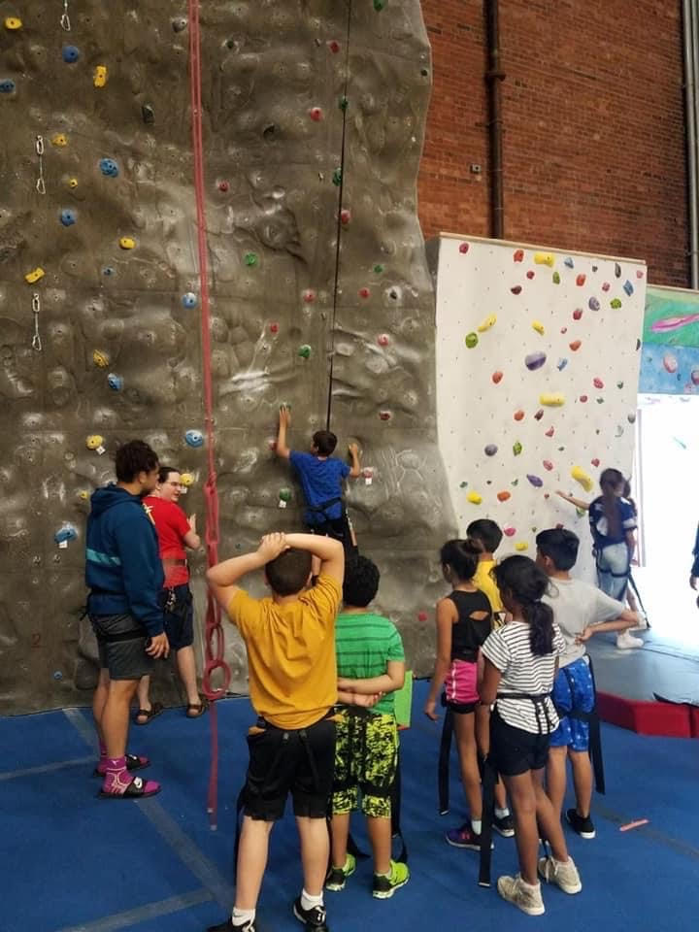

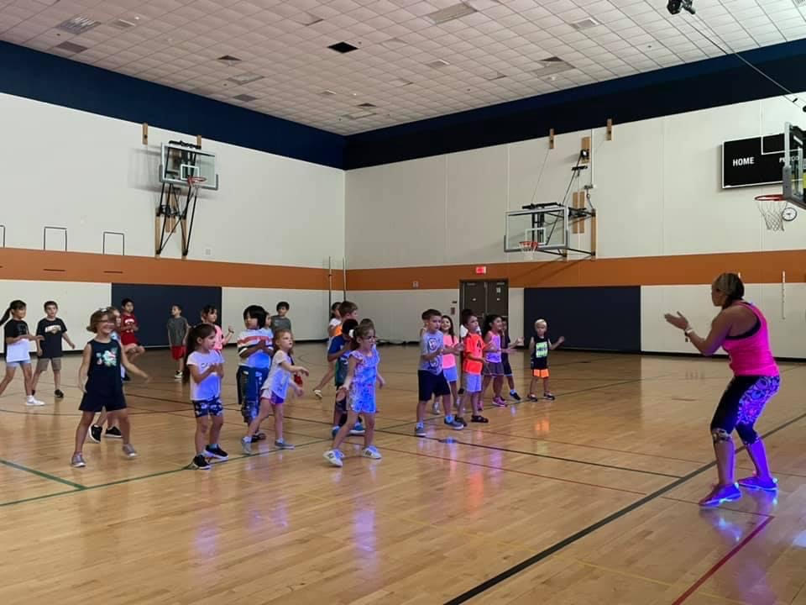

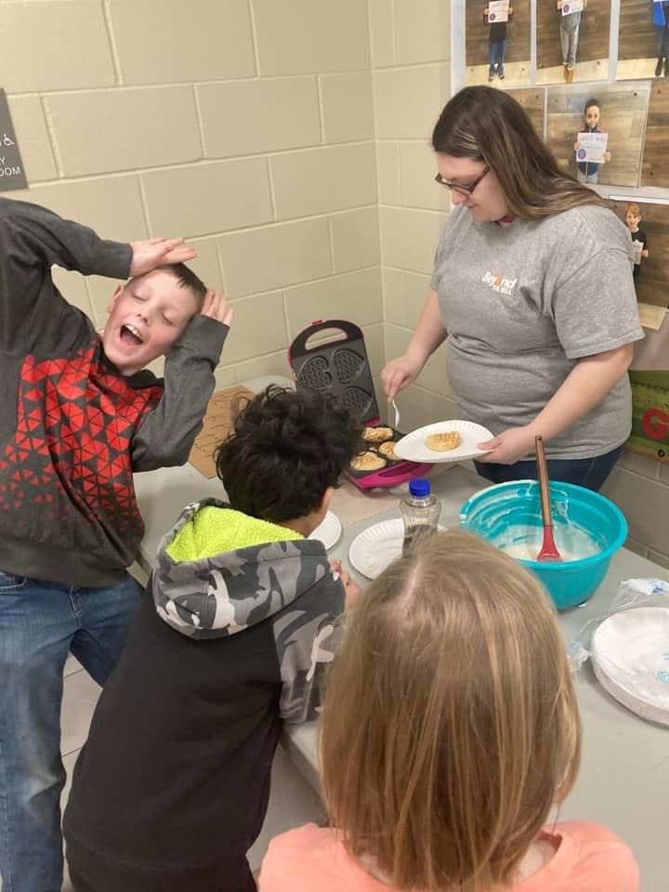

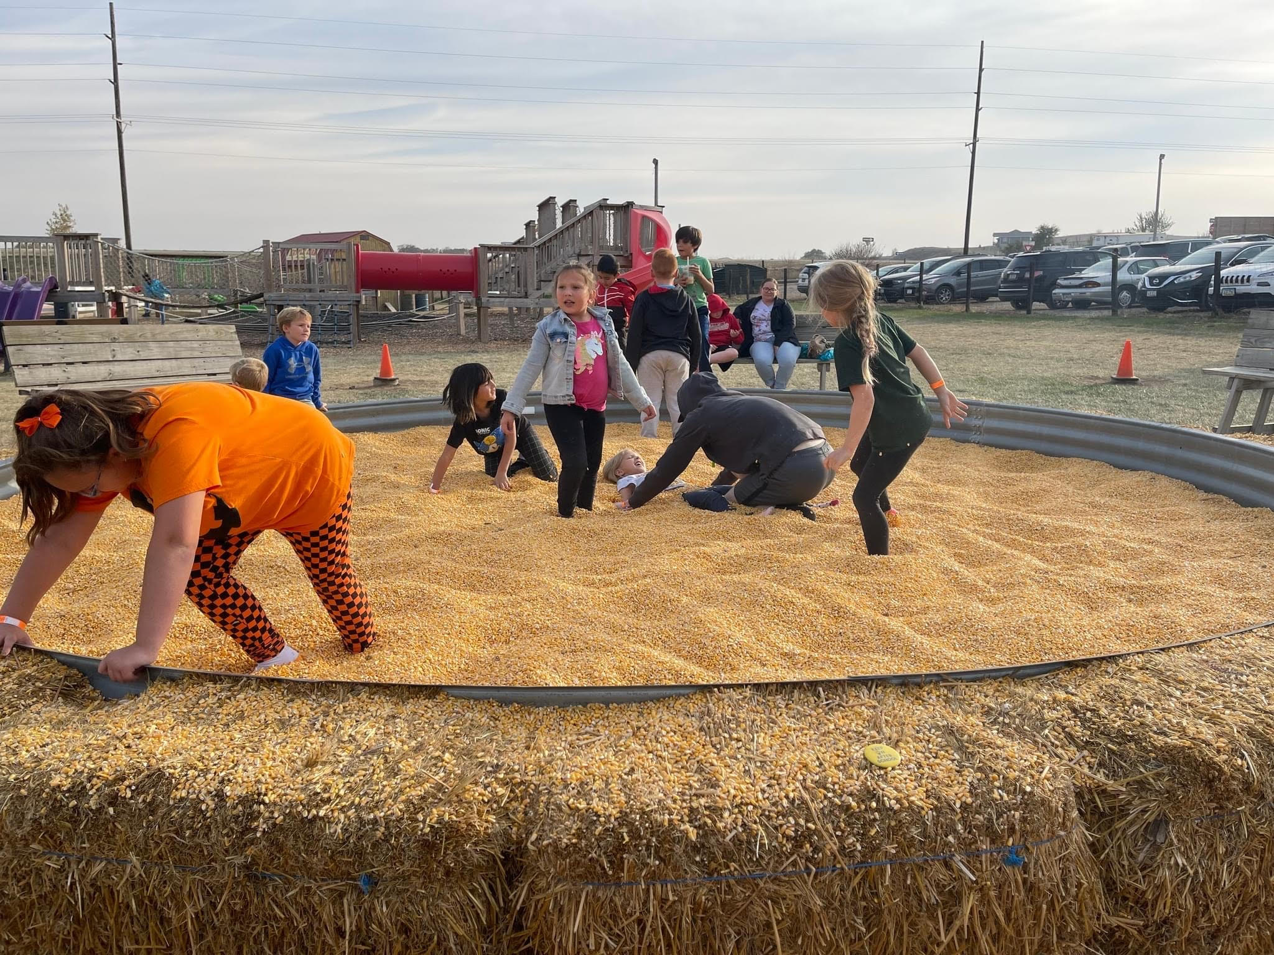

Student, teacher, parent, and stakeholder input
Student, teacher, parent, and stakeholder input Required Elements | Complete?
Quotes from student, teacher, parent, partners, and stakeholders. | x
Quotes should be attributed (titles can be used but names only with permission). | x
Showcase success of the program, especially for student attendance, behavior and academic success. | x

Type or copy and paste student, teacher, parent and stakeholder input here.
Quotes from Students:
“Beyond the Bell has helped me do a better job on my school work.”- Student 6-8
“I get to try new things at BTB and make new friends.”- Student 3-5
Quotes from Teachers:
“The students seem like they look forward to coming to Beyond the Bell after school. They
really enjoy playing games, doing activities, and having free time. The students in our program
get along very well considering that there are multiple students at different grade levels.”- BTB Staff Member

“Students willing to ask staff members for help/assistance on their homework. While their time is
spent at BTB we encourage the students to actively better their education and do their
homework and ask if help is needed.”- BTB Staff Member

Quotes from Parents:
“Love the text announcements, we are very happy with BTB!- BTB Parent

“Programming has been great! This program supports our family need in the gap if
supervision and access to school with work and school schedules. It's an important part of our
routine and support system. And my child loves going!- BTB parent

Quotes from Partners:
Beyond the Bell is able to meet a critical need in the Siouxland area and provide not only safe programming with enrichment and learning activities but community support and programs as well.- Community Partner

Quotes from other Stakeholders (Administrators, Counselors, etc.):
· According to BTB surveys, BTB fulfills a critical unmet school and community need in Siouxland by providing before and after school programming with most respondents indicating the program is “extremely important” or “important.”
· BTB is trusted for its safe, respectful, and child-centered before and after school program.
· BTB is a vital resource for working parents. It provides a safe and interactive outlet for children.

- Sustainability Plans
Sustainability Plans Required Elements | Complete?
Discuss formal sustainability plan from your original grant application including how it has changed. | x
How program will continue without 21st CCLC grant funding. | x
How partnership contributions will help the program continue (refer to partnership table from section 3). | x

Discuss the level of sustainability over the life of the grant. Explain how partner contributions can help sustain the program after federal funding ends.
The original sustainability plans from the applications for 21CCLC grants focused on maintaining current partnerships, developing new partnerships, fundraising, and DHS childcare assistance. BTB uses existing programming to offer the most effective use of public resources.
Formal Sustainability is an ongoing process and BTB takes the following actions to help sustain programs:
- Continue to utilize current partnerships that offer free and low-cost resources and programming to BTB
- Maintain strong relationships with the Sioux City Community School District to maintain in-kind services
- Grow new partnerships within the community
- Continue to invest in and train front line staff to have knowledge of behavior management, communication, and curriculum to be able to manage and maintain quality staff
Sustaining program without 21CCLC programming. At many BTB sites, delivery of before and/or after school programming would not be possible without 21CCLC support and funding. If there were no longer funding from 21CCLC programming would become fee based. BTB would continue to search for and partner with community partners for support, donations, in-kind contributions, and fundraising would support sustainability.
Program partnerships are highlighted in previous sections. Each of these partnerships help maintain and continue programming. In-kind partnerships bring the highest level of sustainability, such as the partnership with the SCCSD providing space and healthy snacks.
Beyond the Bell is continually adding valuable partnerships to all aspects of programming.

- Summary and Recommendations
Summary and Recommendations Required Elements | Complete?
Summary of program. | x
Dissemination of local evaluation. | x
Recommendations for local objectives. | x
Recommendations on future plans for change. | x
Unexpected Data | x

Summary of Program
Summary of Program Required Elements | Complete?
Reference introduction section. | x
Showcase successes of program. | x
Highlight items contributing to program success. | x
Include exemplary contributions from staff, teachers, volunteers and/or partners. | x

Beyond the Bell was established in 2001 as a before school, after school, and summer program provided in Sioux City, Iowa.
Mission: “At Beyond the Bell, we believe in helping children and families reach their full potential by providing a safe place to play, creating a quality learning environment and promoting growth.”
Values: Beyond the Bell provides quality services that are diverse as the communities we call home. We are committed to doing so by offering opportunities to improve the education and life skills built on a foundation of honesty, integrity, and a vision of the future.
Vision: To inspire families and communities to work as one to develop and participate in the education of our youth.
Success of the Program. BTB shows high ratings from feedback in surveys from parents, students, staff, and community partners. The key points consistently endorsed are:
Safety. Key stakeholders show the value of programming located in the student’s home school. BTB meets a critical need of before school, after school and summer programming in the Siouxland community by providing a safe location and high-quality environment for students and families.
Academic Need. Based on the data available and provided to BTB by the SCCSD, students in cohorts 14,15, and 16 showed 83.5% improvement in Reading, 82.1% improvement in Math and an 88.2% improvement in Academic Achievement.
Meaningful and sustainable partnerships. BTB has 12 form partnerships which are in large part a key to the success of programming.
Communication. BTB and the SCCSD have a very positive relationship with communication being instrumental to the program and students’ success.
Program Highlights.
- 128 total students were enrolled in Beyond the Bell for the 2021-2022 school year through the Iowa Department of Education, 21CCLC grant program and 35 additional summer only students. Attendance and data were provided for 128 students and 35 students were enrolled in summer programming through the 21CCLC grant.
- Beyond the Bell helps fill a critical need of before school, after school, and summer programming in the Siouxland community. Parents' responses to surveys state that BTB is of critical importance as an option for a safe out of school learning environment.
- Satisfaction and quality rating of Beyond the Bell is very high.
- Attendance for Beyond the Bell was lower than average. Attendance continues to be affected by the COVID-19 pandemic. Students chose to continue virtual learning, parents no longer had their students attend extra hours of close proximity, parents continued to work from home and their need for programming changed, parents no longer had employment, and finding reliable, consistent, staff to be able to follow all DHS policies and regulations all contributed to the low attendance.
- The Free and Reduced-Lunch Percentage for Cohorts 14, 15, and 16 was 81.12%.
- According to student, staff, and parent surveys the following were stated:
  - 72% of students strongly agree that BTB has helped them explore new ideas or projects
  - 100% of staff state BTB is very important or important in the Siouxland
  - 89.2% of parents strongly agree or agree that the BTB program is a benefit to their child(ren)

Dissemination of Local Evaluation.
Dissemination of Local Evaluation Required Elements | Complete?
Exact URL where your 2021-2022 local evaluation is posted (required by US DOE). Because this is required by ESSA, we check each URL for accuracy. | x
Discussion of other methods of Dissemination (Board reports, community meetings, person to person, e-mail, etc.) | x

Paste exact URL where your 2021-2022 local evaluation is posted (required by US DOE). The URL should pull up the Local Evaluation, not just the page where it can be found. The URL should also not download the file. The Local Evaluation should be readable in the browser window.

Dissemination of evaluation results is key to program enhancement and quality. BTB disseminates local evaluation information through posting evaluation reports on the Beyond the Bell website:
https://www.beyondthebell.us.com/
Beyond the Bell staff receive reports during meetings allowing for discussion regarding program advancement and improvement. Program staff discuss information with the SCCSD staff at their site location through formal and informal communication including monthly staff meetings, newsletters, personal contact, and updates as needed.
BTB presents evaluation findings and recommendations with the SHIP Board, Advisory Committee, parent advisory, and community partners.

Recommendations for Local Objectives.
Recommendations for Local Objectives Required Elements | Complete?
Objectives to be changed and reasons why. | x
Objectives to be added. | x
Include objectives not met. | x
Include objectives not measured. | x

Remember to include an evaluator discussion on how the program met or did not meet the local objectives
Beyond the Bell reported on the following objectives.
Objective A. A majority of BTB families in each cohort participate in Family Literacy Events.
Objective B. At least one BTB parent participates in the BTB Advisory Committee.
Objective C. At least one school staff member participates in the BTB Advisory Committee.
Objective D. In the annual surveys, at least 50% of BTB parents report being satisfied or very satisfied with the level of communication they receive from BTB.
Objective E. At least 50% of program participants attend at least one field trip to a community partner site.
Objectives that were not met but made progress towards were Objective A, B, and C. BTB has been consistently meeting or exceeding the objectives for previous years with the exception of implications of the COVID-19 pandemic.
Objective A. All BTB cohorts held monthly food banks for families and through parent input began family engagement events again. During the school year 4 family engagement events were held and BTB made progress towards the stated objective.
Objective B. This objective was not evaluated during the 2020-2021 school year due to COVID-19 restrictions and safety implications. BTB worked on re-implementing the BTB Advisory Committee in the 2021-2022 school year. This objective was not met but progress was made. BTB sent out surveys to parents regarding a BTB Advisory Committee regarding the need and purpose. The response rate for participation was very low. Each site did regularly communicate with parents that did respond regarding participating and had their own site committee.
Objective C. This objective was not evaluated during the 2020-2021 school year due to COVID-19 restrictions and safety implications. BTB worked on re-implementing the BTB Advisory Committee in the 2021-2022 school year. This objective was not met but progress was made. BTB sent out surveys to SCCSD staff regarding a BTB Advisory Committee regarding the need and purpose. Similar to the parents, the response rate was low. Sites did regularly communicate with SCCSD staff, but no formal meetings were held.
Objectives Met were Objective D and E.

Recommendations on Future Plans for Change.
Recommendations on Future Plans for Changing Required Elements | Complete?
Changes in activities. | x
Changes in recruitment efforts. | x
Changes in partnerships. | x
Changes for sustainability plans. | x
Other changes as suggested by governing body. | x

Remember to include an evaluator discussion of what can be done to improve the program
Based on the results, Beyond the Bell benefits students, families, and the Siouxland Community in an array of ways. Students increase academic achievement, behavior management, and social emotional skills. Families and community partners frequently give positive feedback regarding the program holistically.
Based on the 2021-2022 evaluation, the following future plans have been developed on recommendations.
Continue to reimplement family engagement events, field trips, and advisory committees. As COVID-19 precautions and protocols were changing, students, parents, and staff still had the responsibility to ensure the safety of all involved in BTB programming. Development and implementation began during the 2021-2022 school year to reintegrate these activities to the Beyond the Bell program and BTB will continue to implement these activities while monitoring the safety of all.
Recruitment Efforts. BTB will continue to prioritize students based on referral from the school and community partners and the needs of the child/ren and families. Beyond the Bell is currently applying for funding support. Workforce challenges have significantly impacted BTB in its effort to recruit and retain quality staff to help deliver high quality programming. This has led BTB to assess the capacity numbers and staffing efforts.
Partnerships. Beyond the Bell will continue its community partnership efforts. BTB has 12 key partnerships that are sustainable over time. The continued efforts will continue to be focusing on partner vs vendor, mission alignment, and sustainability. In 2022-2023 BTB is implementing a new partnership with the Community Action Agency of Siouxland. This partnership includes a commitment to participate in family engagement events to communicate services available to BTB families through this community agency. They will be able to help families with things from rent and housing assistance, utility assistance, food, and clothing needs to filling out taxes.
Sustainability plans. Efforts on continuing sustainability planning will remain the same. Sustainability is a constant and active process for the Beyond the Bell program.
Student Leadership. BTB began implementing student governing committees at its 21CCLC sites. BTB will continue to grow the student leadership groups that have been implemented in programming. BTB will work on increasing and enhancing the opportunities that this leadership committee has for the students.

UNEXPECTED DATA (Unusual circumstances that occurred during the past school year- Flood, Tornado, Storm, Pandemic or other) Explain how this affected the program and how you responded to continue to serve children. What new procedures did you introduce? How did the Staff, Students and Parents respond? You may include pictures to help illustrate the challenges faced because of natural disaster.
Beyond the Bell programming resumed to daily in person programming every day school was in session as previously before the COVID-19 pandemic. Challenges arose in many areas as programming resumed to normal day to day operations. Through the changes parent support, communication and strategies were adjusted to promote child, parent, and staff safety.
BTB programming was delivered daily however safety precautions were still followed regarding COVID exposure and sickness. This caused high student and staff absences throughout the school year. BTB increased communication efforts to ensure students, parents, and staff had the knowledge of new protocols, policies, and safety measures.
Families were offered family engagement events and field trips but through communication it was found that the majority of families did not feel safe doing these events often and wanted to maintain a smaller number of events throughout the year.

